Assignment-4

Q1.

Solution

Some of the main features of HTML5 are as follows

Semantic Elements:

HTML5 introduced new semantic elements such as <header>, <nav>, <article>, <section>, <footer>, etc. These elements provide a clearer structure to web documents, making it easier for both developers and browsers to understand the content.

Multimedia Support:

Native support for audio and video elements (<audio> and <video>), allowing developers to embed media content without relying on third-party plugins like Flash.

Canvas Element:

The <canvas> element enables dynamic rendering of graphics and images on the fly, providing a powerful and flexible way to create interactive content, animations, and games.

SVG (Scalable Vector Graphics):

HTML5 includes native support for SVG, allowing developers to embed vector graphics directly into web pages. This is particularly useful for creating scalable and resolution-independent images.

Form Controls:

New input types such as email, URL, date, and range, along with attributes like placeholder and pattern, make form validation and user input easier and more robust.

Local Storage:

The introduction of the localStorage and sessionStorage APIs allows web applications to store data locally on the user's device, providing a more efficient alternative to cookies.

Web Workers:

HTML5 introduced the concept of web workers, which are background scripts that run independently of the main page, enabling multi-threading in web applications and improving performance.

Geolocation:

The Geolocation API enables web applications to access the user's location information, allowing developers to create location-aware applications.

Web Sockets:

HTML5 supports Web Sockets, providing a full-duplex communication channel over a single, long-lived connection. This enables real-time communication between the client and server, facilitating applications like chat and online gaming.

Responsive Web Design:

While not exclusive to HTML5, the new semantic elements, along with CSS3 and JavaScript, contribute to the development of responsive web designs that adapt to various screen sizes and devices.

Offline Web Applications:

HTML5 introduced the Application Cache (AppCache), enabling developers to create web applications that can work offline, improving the user experience in situations with a poor or no internet connection.

Drag and Drop:

HTML5 provides native support for drag-and-drop operations, making it easier to implement intuitive and user-friendly interfaces.

Q2.

Solution

HTML entities are special codes used to represent characters that have a specific meaning in HTML or characters that are reserved for HTML markup. These entities are particularly useful when you want to display characters that may otherwise be interpreted as HTML code. Here are five commonly used HTML entities:

&lt; - Represents the less-than symbol <.

Example: <p>This is an example &lt;em&gt;text&lt;/em&gt;.</p>

&gt; - Represents the greater-than symbol >.

Example: <p>For more information, visit our website &gt; <a href="#">here</a>.</p>

&amp; - Represents the ampersand symbol &.

Example: <p>For further details, contact us &amp; we'll assist you.</p>

&quot; - Represents a double quotation mark "

Example: <p>The title of the book is "The Great Gatsby".</p>

&copy; - Represents the copyright symbol ©.

Example: <p>&copy; 2023 ACME Corporation. All rights reserved.</p>

Q3.

Solution:

Accessibility in web development refers to creating websites and applications that ensure equal access for individuals with disabilities. The goal is to remove barriers to online content for users with visual, auditory, motor, or cognitive impairments. This involves adhering to principles such as providing text alternatives for non-text content, creating operable interfaces, ensuring content is understandable, and using robust coding practices.

Web accessibility is essential for several reasons. Firstly, it promotes inclusivity, offering equal opportunities for all users. Legal compliance is crucial, as many countries require accessibility adherence. Accessible websites expand their audience reach, accommodating users with temporary disabilities or diverse devices. Improved SEO, enhanced usability for all users, and future-proofing against technological changes are additional benefits.

In summary, web accessibility is vital for inclusivity, legal compliance, expanded audience reach, improved SEO, enhanced usability, and future-proofing web development. Prioritizing accessibility ensures a positive user experience for everyone, aligns with legal requirements, and contributes to responsible and ethical web development practice

Q4

Solution:

three ways to improve the accessibility of HTML:

1. Use Semantic HTML:

- Utilize semantic elements (`<header>`, `<nav>`, `<main>`, `<article>`, `<section>`, `<footer>`) to provide a clear document structure. Semantic HTML aids screen readers and other assistive technologies in understanding the content, improving accessibility for all users.

2. Provide Descriptive Text for Links:

- Use meaningful and descriptive text for links by incorporating the `title` attribute or providing additional context within the link text. This helps users using screen readers or navigating via keyboard to understand the purpose of the link.

```html

<a href="example.html" title="Visit the homepage">Home</a>

```

3. Include Text Alternatives for Images:

- Always include descriptive `alt` attributes for images to convey their content or purpose. This is essential for users who rely on screen readers, as the alternative text provides information about the image when it cannot be visually displayed.

```html

<img src="example.jpg" alt="A descriptive text about the content or purpose of the image">

```

These practices contribute to a more accessible and inclusive web experience, ensuring that users with disabilities can effectively navigate, understand, and interact with the content on your website.

Question 5

Solution:

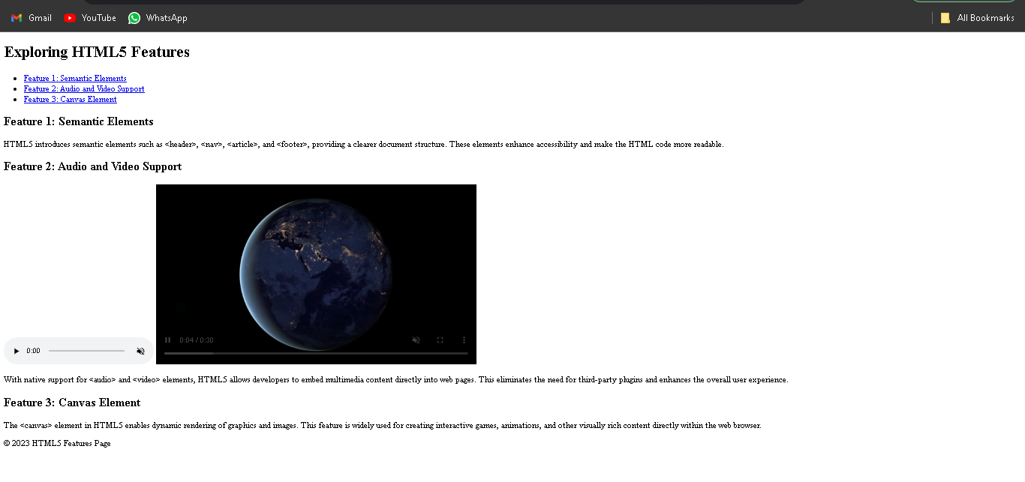

<!DOCTYPE html>

<html lang="en">

<head>

<meta charset="UTF-8">

<meta name="viewport" content="width=device-width, initial-scale=1.0">

<title>HTML5 Features</title>

</head>

<body>

<header>

<h1>Exploring HTML5 Features</h1>

</header>

<nav>

<ul>

<li><a href="#feature1">Feature 1: Semantic Elements</a></li>

<li><a href="#feature2">Feature 2: Audio and Video Support</a></li>

<li><a href="#feature3">Feature 3: Canvas Element</a></li>

</ul>

</nav>

<main>

<section id="feature1">

<h2>Feature 1: Semantic Elements</h2>

<p>

HTML5 introduces semantic elements such as &lt;header&gt;, &lt;nav&gt;, &lt;article&gt;, and &lt;footer&gt;,

providing a clearer document structure. These elements enhance accessibility and make the HTML code more readable.

</p>

</section>

<section id="feature2">

<h2>Feature 2: Audio and Video Support</h2>

<audio src="https://www.learningcontainer.com/wp-content/uploads/2020/02/Kalimba.mp3" controls muted autoplay

loop>Kalimba Audio</audio>

<video src="https://file-examples.com/storage/fee4e04377657b56c9a6785/2017/04/file_example_MP4_640_3MG.mp4" controls muted autoplay

loop></video>

<p>

With native support for &lt;audio&gt; and &lt;video&gt; elements, HTML5 allows developers to embed multimedia content

directly into web pages. This eliminates the need for third-party plugins and enhances the overall user experience.

</p>

</section>

<section id="feature3">

<h2>Feature 3: Canvas Element</h2>

<p>

The &lt;canvas&gt; element in HTML5 enables dynamic rendering of graphics and images. This feature is widely used for

creating interactive games, animations, and other visually rich content directly within the web browser.

</p>

</section>

</main>

<footer>

<p>&copy; 2023 HTML5 Features Page</p>

</footer>

</body>

</html>

Q6.

Solution:

Output

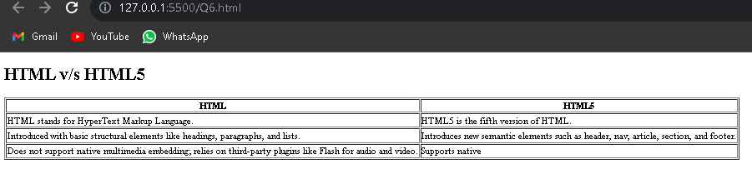

Code:

<!DOCTYPE html>

<html lang="en">

<head>

<meta charset="UTF-8" />

<meta http-equiv="X-UA-Compatible" content="IE=edge" />

<meta name="viewport" content="width=device-width, initial-scale=1.0" />

<title>HTML v/s HTML5</title>

</head>

<body>

<h1>HTML v/s HTML5</h1>

<table border="1">

<tr>

<th>HTML</th>

<th>HTML5</th>

</tr>

<tr>

<td>HTML stands for HyperText Markup Language.</td>

<td>HTML5 is the fifth version of HTML.</td>

</tr>

<tr>

<td>Introduced with basic structural elements like headings, paragraphs, and lists.</td>

<td>Introduces new semantic elements such as header, nav, article, section, and footer.</td>

</tr>

<tr>

<td>Does not support native multimedia embedding; relies on third-party plugins like Flash for audio and video.</td>

<td>Supports native <audio> and <video> elements for embedding audio and video content without plugins.</td>

</tr>

</table>

</body>

</html>